

DEPARTMENT OF COMPUTER SCIENCE AND ENGINEERING

OPERATING SYSTEMS - CS235AI

REPORT
Topic : Customizing Bootloader Program

Submitted by

SHREEHARI G BHAT 1RV22CS186
VISHRUTH V 1RV22CS233

Computer Science and Engineering

2023-2024
CONTENTS

- Problem Statement
- Introduction
- Steps of a boot process
- Methodology
- Software Components
- Results
- Future Scope
- References

- Problem Statement
This project focuses on the development and customization of a bootloader, addressing the need for enhancing its functionality beyond conventional bootstrapping tasks. Bootloaders play a crucial role in initializing the system and loading the operating system kernel, making them a critical component in the boot process. The primary objective is to explore the modification and compilation process of the bootloader, with the aim of extending its capabilities and improving system boot performance.
By actively engaging with bootloader development and customization, this project seeks to deepen understanding of bootloader mechanisms and contribute to advancements in system bootstrapping techniques. Through rigorous experimentation and analysis, the project aims to enhance the reliability and performance of bootloaders, thereby ensuring efficient system initialization and improved user experience.

Introduction
Memory leak occurs when dynamically allocated memory or objects are not properly freed even if they are no longer accessed. This can happen when memory fragments or objects become unreachable or obsolete.
Detecting memory leak presents challenges, particularly in determining whether an object will be utilized in future program executions. As a result, memory leak tends to focus on observable effects such as increasing memory consumption. However, this approach has limitations as it takes significant time for memory leaks to manifest and their occurrence can be contingent in the production environment making them threats to long running applications.
There are two problems related to Memory: Memory corruption and Memory Leak. Java has garbage collector. So, it does not allow programmers to access the physical memory directly, but C / C++ does. So, Java does not suffer from memory corruption. A memory leak occurs when a process allocates memory and while releasing does not free the memory. As a result, memory is depleted over time and causes slowing down of the system.
The Memory Leak Detector (MLD) will be implemented as a library which will keep track of Heap Objects the application has created and how they hold references. MLD library will show the leaked objects.

3.Boot process steps
Normally, when a Boot strap is called
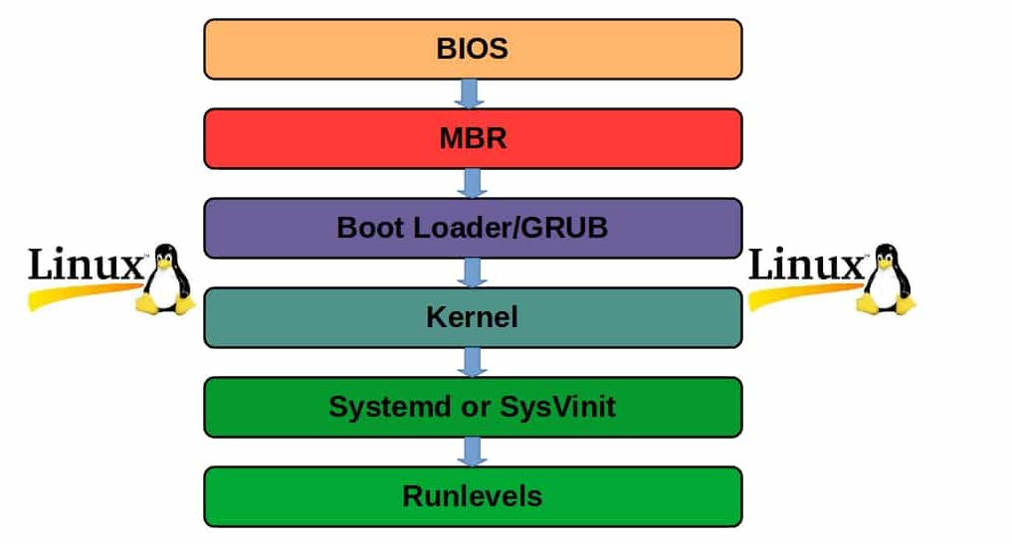
- BIOS (Basic Input/Output System):
  - The BIOS is the firmware responsible for initializing hardware components during the boot process. When the computer is powered on, the BIOS executes the Power-On Self-Test (POST) to check hardware integrity. It then locates and loads the bootloader from the boot device.
- MBR (Master Boot Record):
  - The Master Boot Record is a special sector located at the beginning of a storage device (such as a hard disk or SSD). It contains the bootloader code, which is responsible for loading the operating system kernel into memory. The MBR also contains a partition table describing the layout of the disk.
- Bootloader:
  - The bootloader is a small program stored in the MBR or a designated boot partition. Its primary function is to load the operating system kernel into memory and transfer control to it. The bootloader typically performs tasks such as initializing hardware, locating the kernel, and setting up the environment for the operating system.
- Kernel:
  - The kernel is the core component of the operating system responsible for managing system resources, providing essential abstractions for user programs, and handling hardware interactions. Once loaded by the bootloader, the kernel takes control of the system and initializes the rest of the operating system.
- Init System
  - After the kernel initializes, some operating systems utilize an init system (such as systemd or SysVinit) to manage system services, start daemons, and initialize user space processes.
These levels represent key stages in the boot process, each with its specific role in initializing the system and preparing it for user interaction.
4.Methodology
- Requirement Analysis:
  - Begin by analyzing the requirements and objectives of the bootloader project. Determine the specific functionalities and enhancements needed for the bootloader, considering factors such as system compatibility, performance, and extensibility.
- Research and Study:
  - Conduct in-depth research on bootloader development, including studying existing bootloader implementations, relevant documentation, and resources. Gain insights into bootloader architecture, functionality, and best practices.
- Design Phase:
  - Design the architecture and structure of the custom bootloader, taking into account the identified requirements and research findings. Define the modules, data structures, and interfaces needed to implement the desired functionalities.
- Implementation:
  - Write the bootloader code according to the design specifications. Use assembly language (e.g., x86 assembly) or low-level programming languages (e.g., C) depending on project requirements and platform compatibility. Implement features such as hardware initialization, filesystem support, user interaction, and error handling.
- Testing and Debugging:
  - Conduct thorough testing of the bootloader code to ensure correctness, reliability, and compatibility with target systems. Test the bootloader on various hardware configurations and virtual environments (e.g., QEMU emulator) to validate its functionality under different scenarios. Debug any issues encountered during testing.
- Integration:
  - Integrate the custom bootloader with the existing boot process or system environment. Ensure seamless integration with the system firmware (BIOS or UEFI), MBR (Master Boot Record), and operating system kernel. Verify that the bootloader operates correctly within the boot sequence.
- Performance Evaluation:
  - Evaluate the performance of the custom bootloader in terms of boot time, resource utilization, and system responsiveness. Compare the performance metrics with standard bootloader implementations to assess the effectiveness of the custom enhancements.
is given below,

5. Software Components
- NASM (Netwide Assembler):
  - NASM is a popular assembler used to write and assemble assembly language code. It supports various output formats and instruction sets, making it suitable for generating machine code for different architectures.
  - In the bootloader project, NASM is used to write and assemble assembly language code for the bootloader. It translates the assembly code into machine code that can be executed by the computer's hardware.
  - NASM is a critical tool for low-level development, enabling developers to directly interact with hardware components and write efficient code for bootloader functionality.
- QEMU (Quick Emulator):
  - QEMU is an open-source emulator that allows the emulation of various CPU architectures and hardware platforms. It is commonly used for system emulation, virtualization, and development testing.
  - In the bootloader project, QEMU is used to emulate the target hardware environment for testing the bootloader code. It provides a virtualized environment where developers can run and debug the bootloader without the need for physical hardware.
  - QEMU supports emulation of x86 architecture, making it suitable for testing bootloader code written for x86-based systems.
- C Programming IDE -VS CODE
  - C programming language is a widely used programming language known for its efficiency, portability, and low-level system access capabilities.
  - In the bootloader project, C programming language may be used for various purposes, such as implementing bootloader functionalities beyond basic assembly code, integrating with assembly code, or writing utility programs for bootloader development and testing.
  - C programming language offers high-level abstractions and allows developers to write structured and maintainable code, making it a valuable tool in bootloader development alongside assembly language.
- Linker:
  - A linker is a software tool that combines multiple object files generated by an assembler or compiler into a single executable program or library. It resolves symbolic references between object files, assigns final memory addresses to program code and data, and generates the necessary executable file format (e.g., ELF, PE).
  - In the bootloader project, a linker is used to link together the bootloader code, any additional object files, and external libraries (if applicable) into a final executable binary file. This binary file can then be loaded and executed by the system firmware during the boot process.
  - Common examples of linkers include GNU ld (Linker from GNU Binutils) and Microsoft Linker (for Windows development). These tools provide options for specifying linker scripts, entry points, and output formats to customize the linking process according to project requirements.

- Loader:
  - A loader is a system component responsible for loading executable programs or libraries into memory and preparing them for execution by the CPU. It reads the executable binary file from storage, allocates memory space for program code and data, resolves dynamic linking references, and sets up the program's initial execution context.
  - In the context of bootloader development, the loader functionality is typically handled by the system firmware (BIOS or UEFI) or by the operating system kernel. During the boot process, the bootloader loads the operating system kernel into memory and transfers control to it, effectively acting as a loader for the kernel.
  - While bootloader developers may not directly interact with loaders, understanding loader functionality is essential for ensuring proper integration of the bootloader with the rest of the boot process and the operating system environment.

6.Results
A simple bootloader was developed
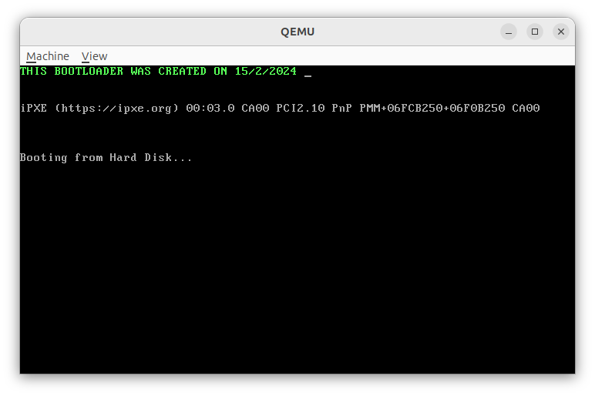

With interrupt handling
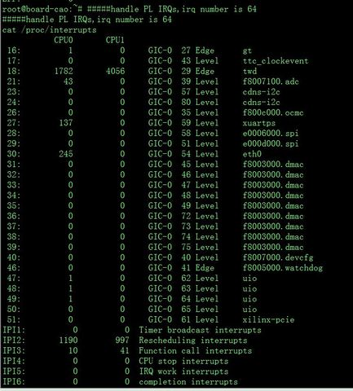

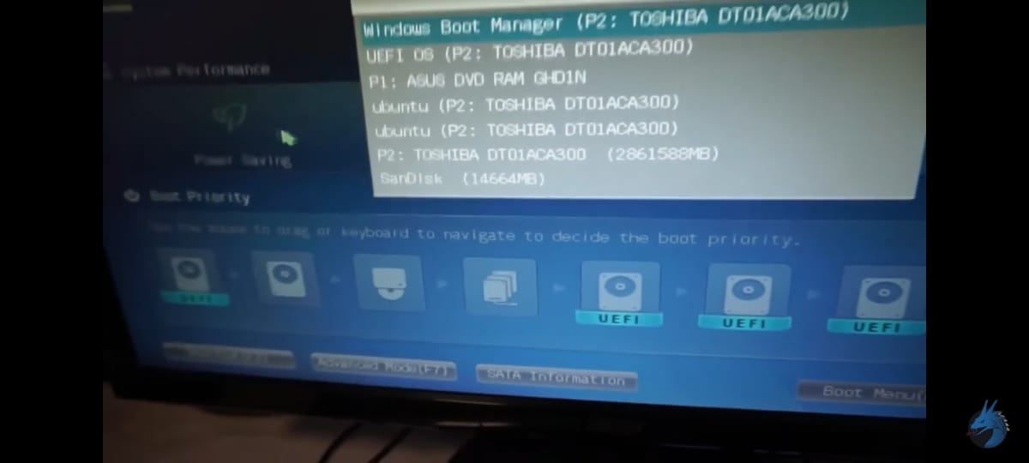

7.Future scope
- Multiboot Support:
  - Enhance the bootloader to support loading and booting multiple operating systems or kernels. Implementing the Multiboot specification can enable compatibility with a wider range of operating systems.
- User Interface Improvements:
  - Develop a more user-friendly interface, such as a graphical boot menu with options for selecting different operating systems or boot configurations.
- File System Support:
  - Add support for reading files from a file system, such as FAT or ext4, to load kernel images or other data files. This could involve implementing file system drivers within the bootloader.
- Boot Configuration:
  - Implement a configuration mechanism to allow users to customize boot options, such as kernel parameters or boot-time settings.
- Boot Performance Optimization:
  - Optimize the bootloader code and boot process to reduce boot time and improve overall system startup performance.

8.References
- "Intel 64 and IA-32 Architectures Software Developer's Manual" (Intel)
- "Programming with 64-Bit Intel® Core™ Processors" by Vladimir Brazhnikov and Anatoly Korniltsev
- "OSDev Wiki"
- "Bare Bones" by Nick Blundell
- "The Art of Assembly Language Programming" by Randall Hyde
- Online forums and communities

